**EXPERIMENT -6**

**DML COMMANDS (COLLEGE SCHEMA)**

**AIM:**

1.insert 5 instances in to the tables created in experiment 6.

2.Display the tables.

3.add attribute course to the table then insert values.

4.use update to set course for students.

5.delete an attribute.

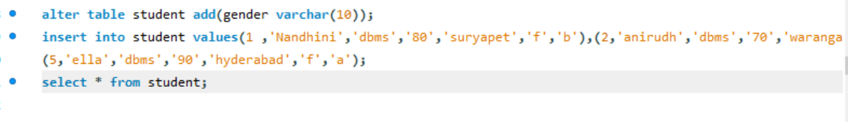

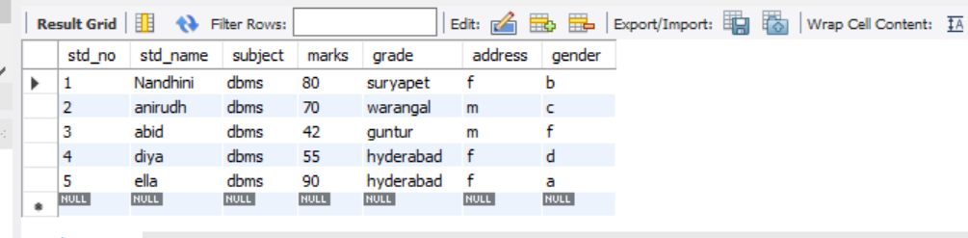

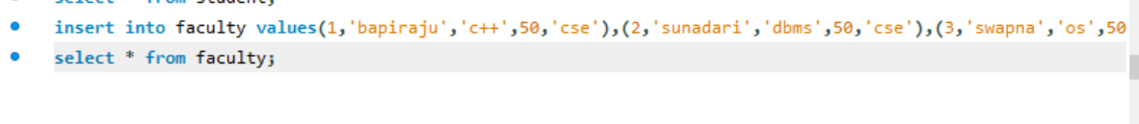

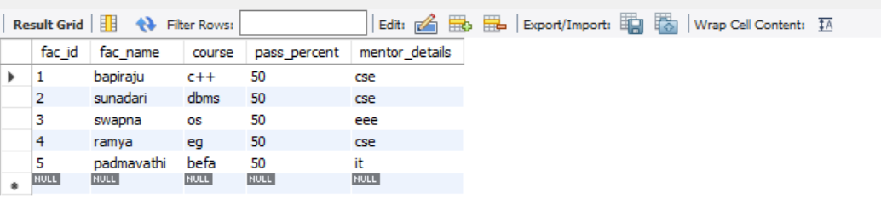

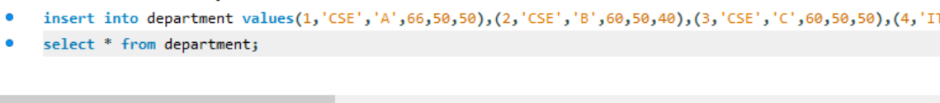

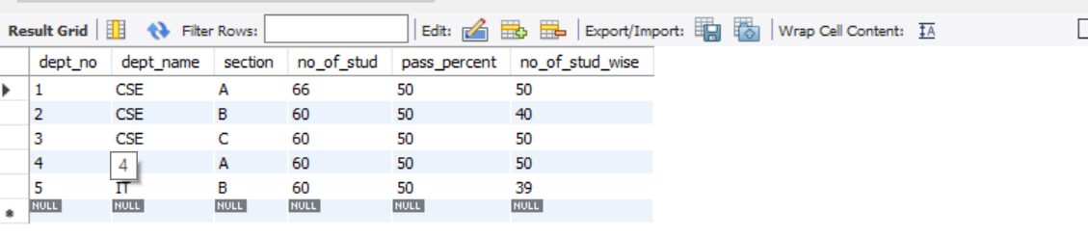

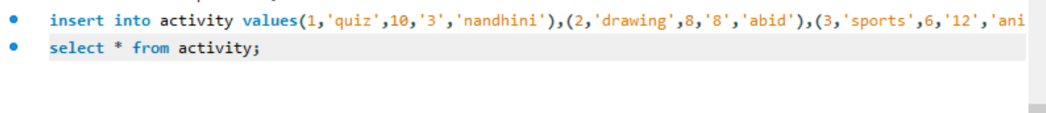

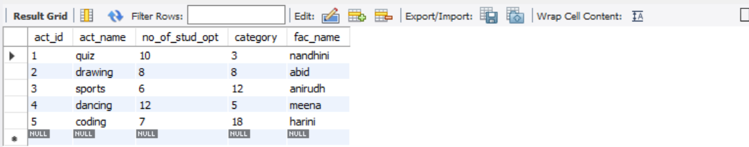

3 & 4.

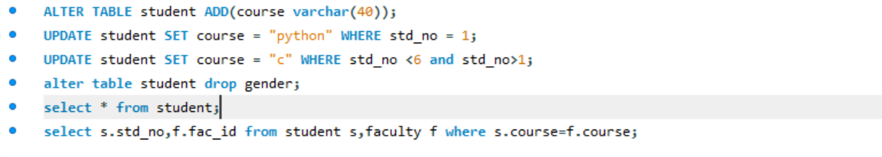

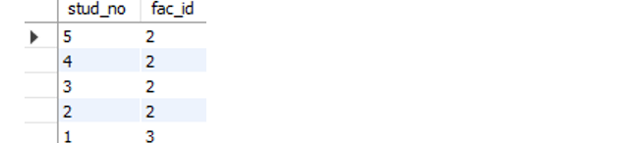

5.

